**電通二甲微處理器實驗 實驗結報**

|  |  |  |  |
| --- | --- | --- | --- |
| **實驗名稱** | **labn04** | | |
| **組別** |  | **組員** | **林智偉/06050704** |

**實驗目的**

了解七段顯示器之原理

共陰極與共陽極七段顯示器的不同

如何讓7短顯示器顯示 0-F

如何控制四合一7段顯示器

如何讓四合一7段顯示器顯示四位數字

**實驗步驟**

將4合一7段顯示器依序跟ARDUINO接好，並撰寫與題目相符的程式

**電路圖**

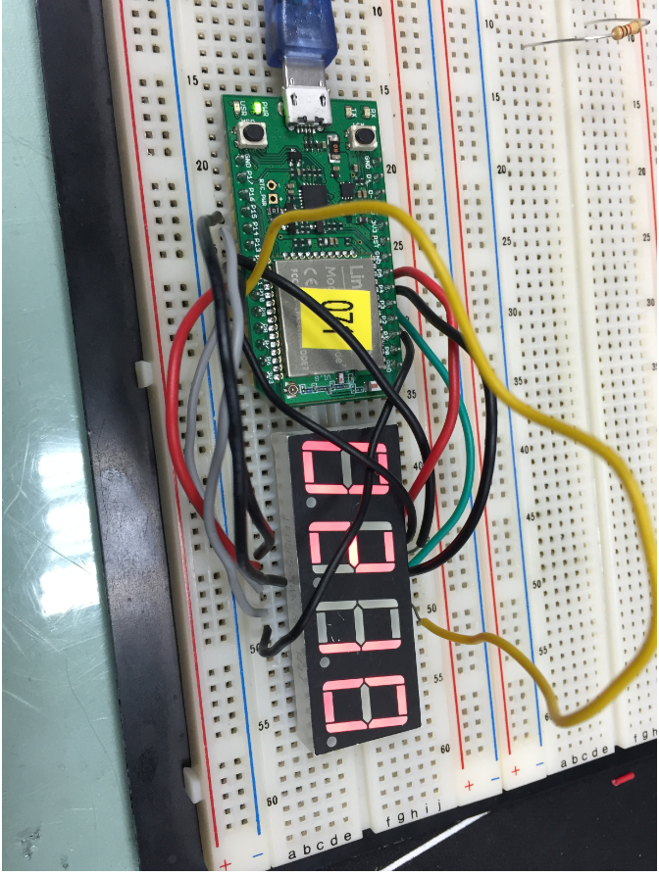

**程式碼**

**---1**

#include "SevSeg.h"

SevSeg sevseg;

static unsigned long timer = millis();

static int deciSeconds = 0;

byte a=0;

byte i;

byte b=0;

void setup() {

byte numDigits = 4;

byte digitPins[] = {2, 3, 4, 5};

byte segmentPins[] = { 8, 9, 10, 11, 12, 13,14,15};

bool resistorsOnSegments = false;

byte hardwareConfig = COMMON_CATHODE;

bool updateWithDelays = false;

bool leadingZeros = false;

pinMode(6, INPUT);

sevseg.begin(hardwareConfig, numDigits, digitPins, segmentPins, resistorsOnSegments, updateWithDelays, leadingZeros);

sevseg.setBrightness(90);

Serial.begin(9600);

}

void loop() {

if (millis() - timer >= 100) {

timer += 100;

deciSeconds++;

b=deciSeconds%100;

if (b % 60 == 0)

{

a++;

deciSeconds=0;

Serial.println(a);

for(i=0;i<a;i++)

deciSeconds+=100;

}

if (deciSeconds == 2359) {

deciSeconds=0;

}

sevseg.setNumber(deciSeconds);

}

sevseg.refreshDisplay();

}

**---2**

#include "SevSeg.h"

SevSeg sevseg;

static unsigned long timer = millis();

static int deciSeconds = 0;

byte a=0;

byte i;

byte b=0;

void setup() {

byte numDigits = 4;

byte digitPins[] = {2, 3, 4, 5};

byte segmentPins[] = { 8, 9, 10, 11, 12, 13,14,15};

bool resistorsOnSegments = false;

byte hardwareConfig = COMMON_CATHODE;

bool updateWithDelays = false;

bool leadingZeros = false;

pinMode(6, INPUT);

sevseg.begin(hardwareConfig, numDigits, digitPins, segmentPins, resistorsOnSegments, updateWithDelays, leadingZeros);

sevseg.setBrightness(90);

Serial.begin(9600);

}

void loop() {

if (6 == LOW) b = a = 0;

if (millis() - timer >= 100) {

timer += 100;

deciSeconds++;

b=deciSeconds%100;

if (b % 60 == 0)

{

a++;

deciSeconds=0;

Serial.println(a);

for(i=0;i<a;i++)

deciSeconds+=100;

}

if (deciSeconds == 2359) {

deciSeconds=0;

}

sevseg.setNumber(deciSeconds);

}

sevseg.refreshDisplay();

}

**---3**

#include "SevSeg.h"

SevSeg sevseg;

void setup() {

byte num2[]={5,4,3,2};

byte pin[]={8,9,10,11,12,13,14,15};

sevseg.begin(COMMON_CATHODE,4,num2,pin,false,false,false);

sevseg.setBrightness(90);

pinMode(6,INPUT);

pinMode(7,INPUT);

}

void loop() {

static int Min=0,Hour=0;

static unsigned long timer = millis();

int sum=0;

if(digitalRead(6))

{

if(millis()-timer>100)

{

timer+=100;

sevseg.setNumber(Hour*100+Min,2);

if(--Min<=0)

{

Min=59;

if(--Hour<=0)

Hour=23;

}

}

sevseg.refreshDisplay();

}

else

{

if(millis()-timer>100)

{

timer+=100;

sevseg.setNumber(Hour*100+Min,2);

if(++Min>=60)

{

Min=0;

if(++Hour>=24)

Hour=0;

}

}

sevseg.refreshDisplay();

}

}

**實驗結果及分析**

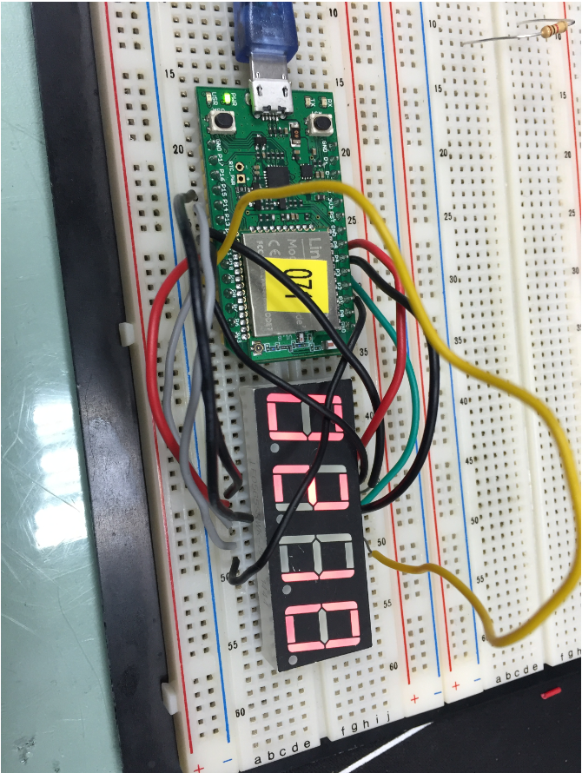

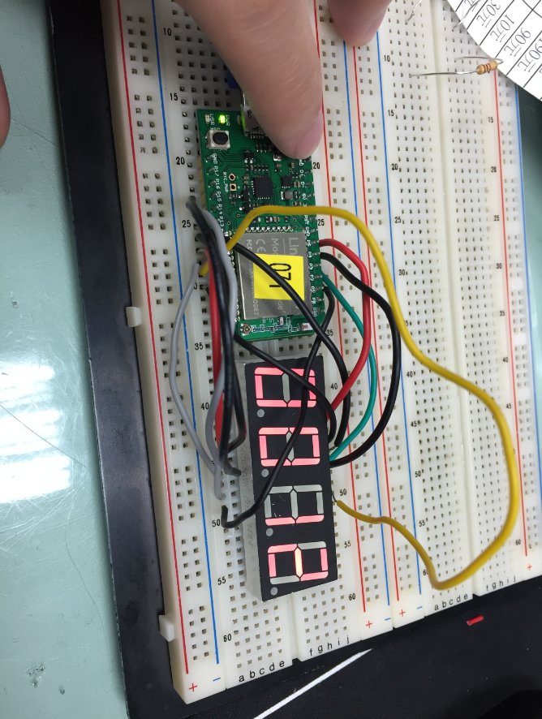

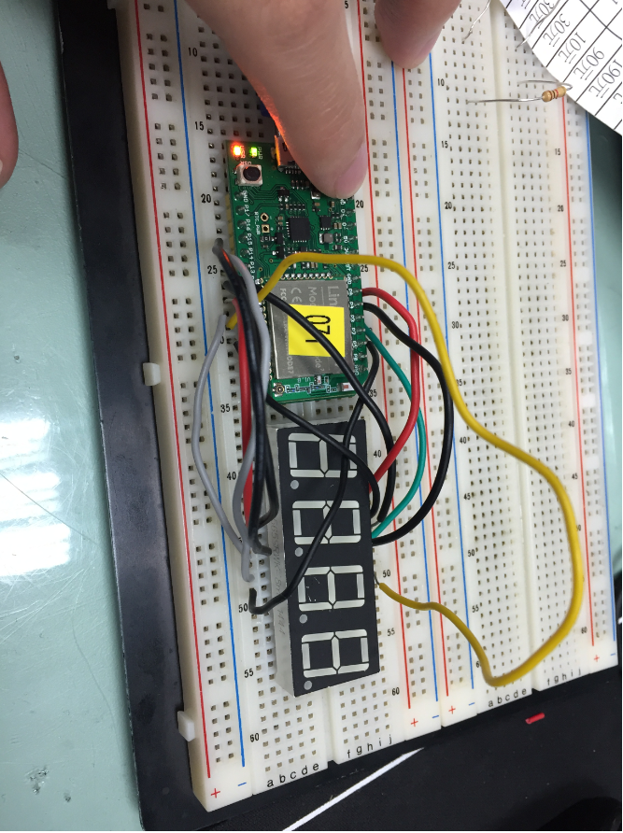

**心得討論**

**這次的實驗有一點的挑戰，並不能在三節課的時間內做完，之後要在更努力了。**